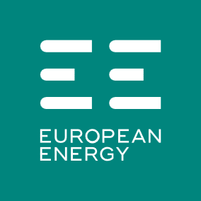
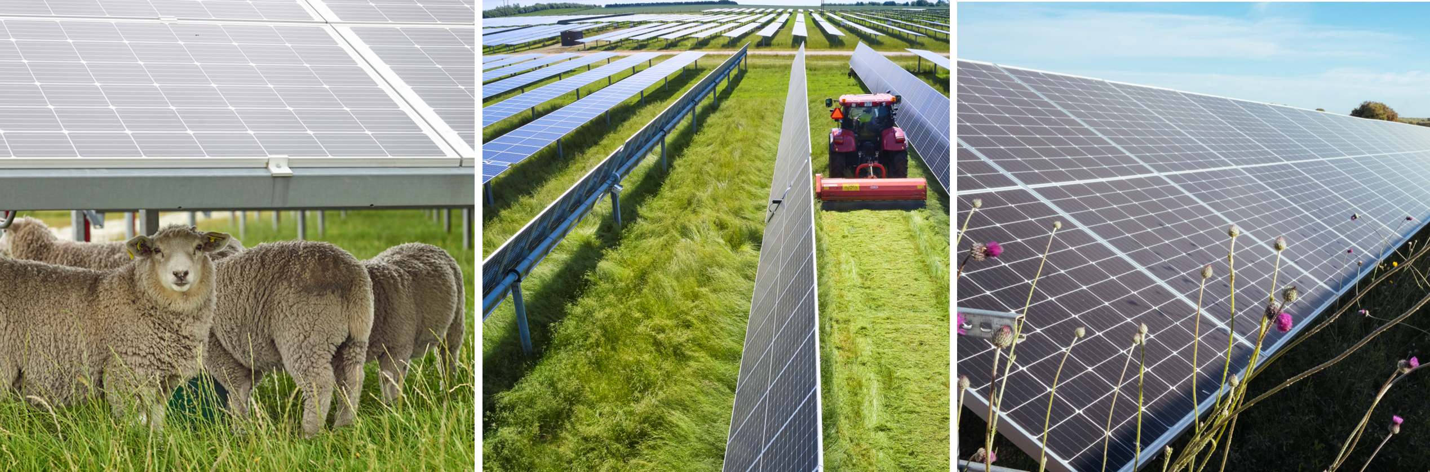

Tregonning Solar Farm
Dear Resident,

We would like to invite you to a community information meeting on Wed 18/03/2026 about the upcoming construction of the solar farm on land at Tregonning Farm, Kestle Mill.

This meeting is an opportunity for us to introduce the project team, share clear and up‑to‑date information, and ensure the local community remains informed as the project moves into its construction phase.

At the meeting, the project team will deliver a presentation covering:
- An overview of the solar farm
- The upcoming stages of construction and delivery
- How the project will operate once completed
Following the presentation, there will be time to ask questions, speak directly with members of the team, and discuss any points you’d like to raise.

Event Details:

Date: Wed 18/03/2026
Venue: St Newlyn East Village Hall – Main Hall
Doors open: 5:30pm
Presentation and Q&A: 5:45pm–6:45pm
Extended discussion & questions: 6:45pm–8:00pm (Hawken Rowse Meeting Room)
You are welcome to join us for the full session or drop in later for the extended discussion period.

Community Engagement
We remain committed to open, transparent communication with the community. If you have any questions or concerns, please feel free to get in touch. Further information on all our projects, including Tregonning Solar Farm is available and regularly updated on our website: https://uk.europeanenergy.com/our-projects/

Kind regards,

Lisa Wilson
Project Communicatons Manager
liwi@europeanenergy.com

